Technical Analysis Report: ASIC Physical Design
Project: 4-Bit Counter Physical Implementation

1. Metric Summary
- Setup WNS / TNS: 8.335 ns / 0.000 ns
- Hold WNS / TNS: 0.026 ns / 0.000 ns
- Clock Skew: 0.000 ns (From Innovus CTS)
- Total Power: 11.56 µW (From Innovus Power Analysis)
- LVS Match Status: MATCH (Clean Extraction, 0 ERC Errors)
- DRC & Connectivity: 0 Violations

2. Command Log
- Design Initialization: init_design compiled the TSMC 65nm LEF files, Genus netlist, and MMMC constraints to build the physical database.
- Floorplanning & Power Network: create_floorplan, add_rings, and add_stripes defined the chip boundary and synthesized the VDD/VSS power delivery network to prevent IR drop.
- Placement & Pre-CTS Optimization: place_opt_design placed the 22 standard cells to minimize wirelength. opt_design -pre_cts closed initial setup timing with 0 DRVs.
- Clock Tree Synthesis (CTS): ccopt_design built the clock tree to the 4 flip-flop sinks, achieving zero skew.
- Routing & Post-Route Optimization: route_opt_design connected all 17 data nets. opt_design -post_route performed final SI-aware timing closure using detailed RC extraction.
- DFM & Physical Continuity: route_design -via_opt upgraded 74.4% of vias to multi-cut for reliability. add_fillers inserted 9 dummy cells to ensure N/P well continuity.
- Innovus Signoff Checks: check_drc and check_connectivity confirmed 0 physical/electrical violations.
- Standalone STA (Tempus): report_timing -late and report_timing -early extracted the top critical paths for setup and hold using the SPEF parasitics, while report_constraint audited the final design rules.

3. Layout Screenshots
Ensure the Innovus GUI is configured to show the relevant layers for each milestone.
A. Floorplan (Rings & Stripes)
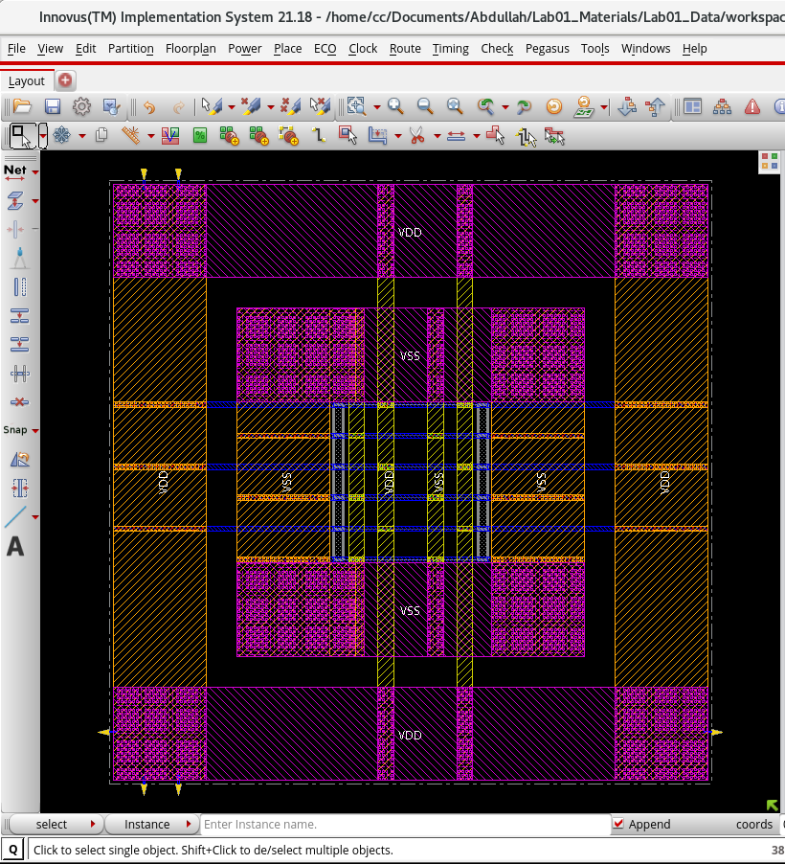

B. Placement
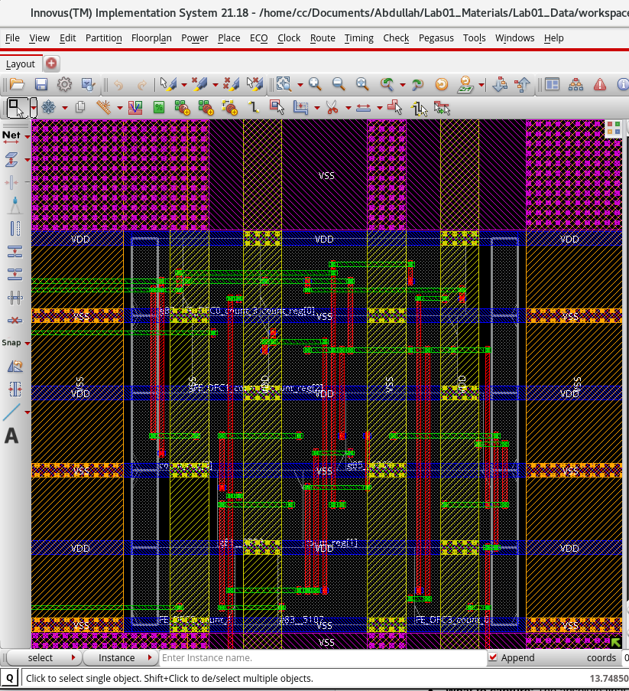

C. CTS (Clock Tree Highlighted)
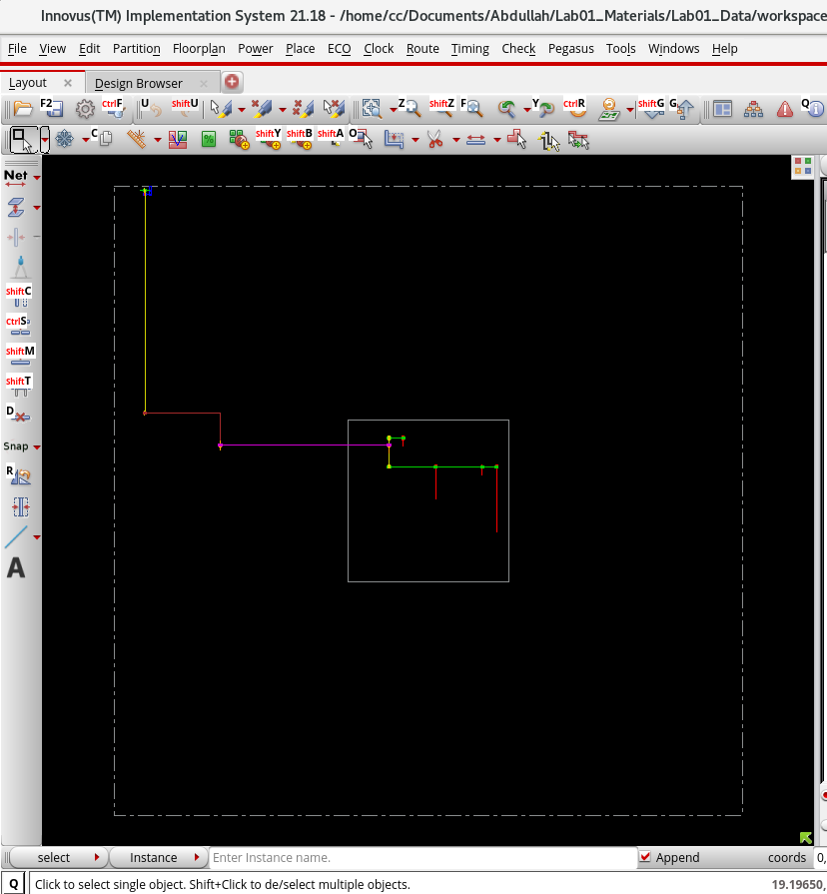

D. Routing
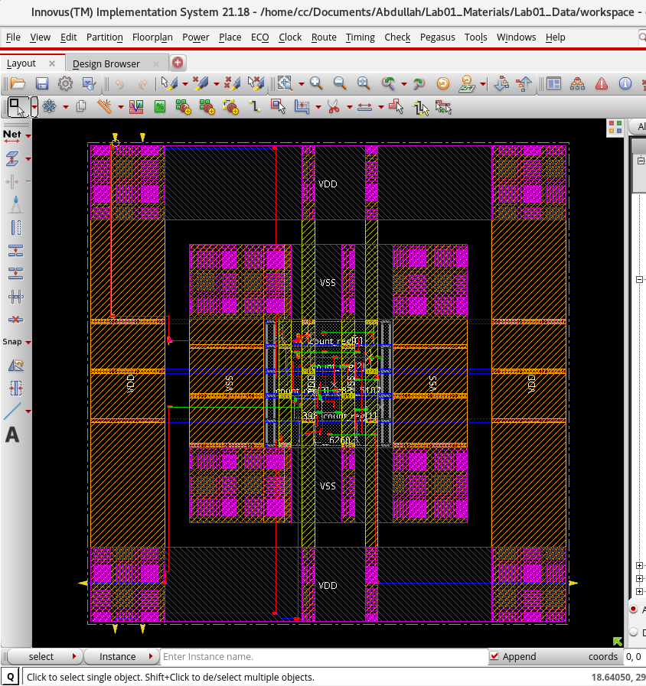

E. Final GDS (Fillers & Decaps included)
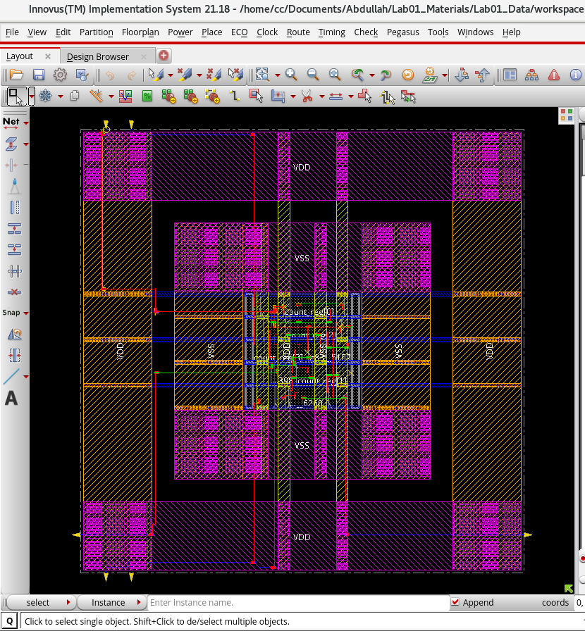

4. Backend Formal Verification Analysis (LEC)
A. Post-Placement LEC Screenshots
- Primitives Table:
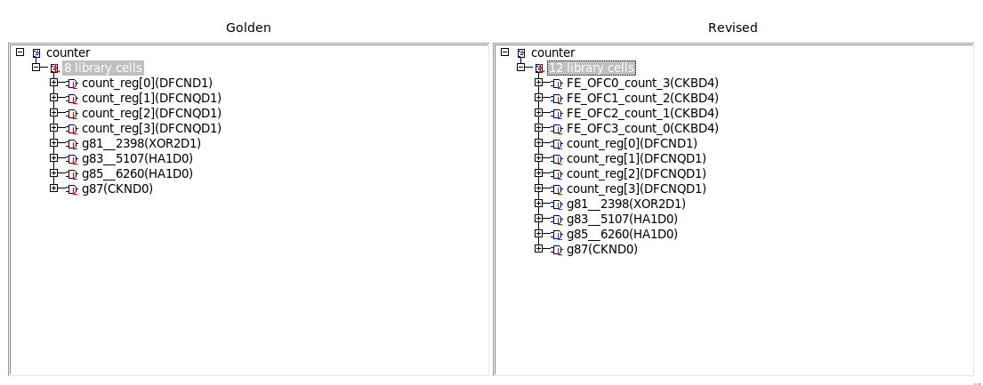
- Compared Points:
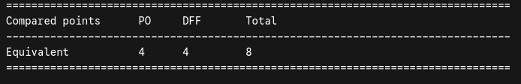
B. Post-CTS LEC Screenshots
- Primitives Table:
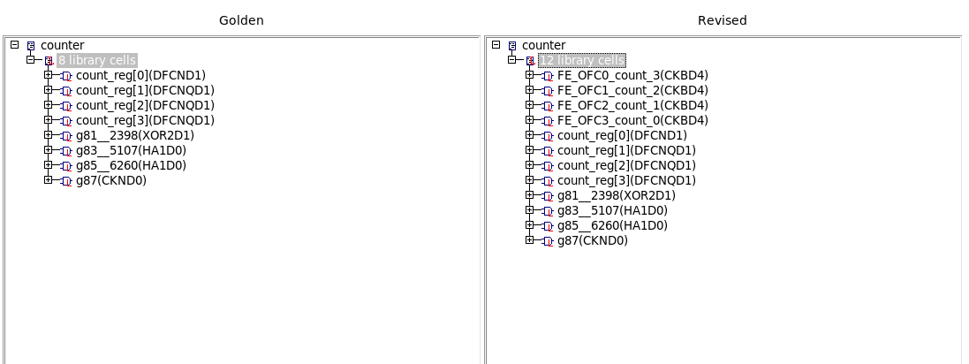
- Compared Points:
C. Post-Route LEC
- Final Equivalence Verification:
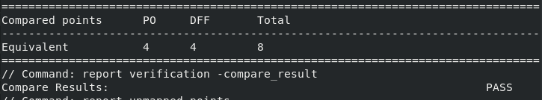
Analysis of Primitive Count Changes:
Although the design remained mathematically equivalent (Boolean logic was unaltered), the primitive count increased from 8 library cells to 12 library cells between the Post-Placement and Post-CTS stages. During the placement phase, the clock network is treated as an "ideal" net with no physical delays. However, during Clock Tree Synthesis (CTS), the physical clock distribution network is built. The Innovus ccopt_design engine physically inserted four standard cell clock buffers (CKBD4) into the netlist to distribute the clock signal to the four flip-flops evenly, ensuring zero skew. Conformal identifies these newly inserted clock buffers as new primitives, causing the count to jump.

5. Signoff Static Timing Analysis (Tempus)
The final routed netlist and extracted SPEF parasitics were analyzed in a standalone Tempus environment. The design successfully achieved timing closure across all views.
A. Timing Summary
- Setup: The critical setup path spans from count_reg[1]/CP to the count[1] output port. The design meets the 100MHz target frequency with a comfortable Worst Negative Slack (WNS) of 8.335 ns and a Total Negative Slack (TNS) of 0.000 ns.
- Hold: The critical hold path spans from count_reg[0]/CP to count_reg[0]/D. The data is held stable long enough to prevent race conditions, achieving a WNS of 0.026 ns and TNS of 0.000 ns.
B. Design Rule Violations (DRV) The layout successfully passed all electrical signoff rules.
- Max Capacitance: 0 Violations (Slack: +0.026)
- Max Transition: 0 Violations (Slack: +0.155)
- Max Fanout: 0 Violations (Slack: +6.000)

6. Physical Verification (LVS)
To confirm that the final physical geometries accurately represent the logical intent of the design, a Layout Versus Schematic (LVS) check was performed using Cadence Physical Verification System (PVS). The tool utilized the TSMC 65nm spice models (`tcbn65lp_200a.spi`), the structural Verilog netlist, and the final GDSII layout.

A. Electrical Rule Checking (ERC)

During the geometric extraction phase, PVS performed a suite of Electrical Rule Checks to identify catastrophic physical flaws prior to netlist comparison.
- Floating Nets: Checked for isolated N-wells (`nxwell`) and P-substrates (`psub`) lacking proper power or ground tie-offs.
- Result: All 9 ERC checks completed successfully with **0 errors**, confirming robust physical power distribution.

B. Netlist Versus Netlist (NVN) Comparison

The PVS engine mathematically extracted the devices from the GDSII polygons and compared them node-for-node against the Verilog schematic.
- Layout Instances Extracted: 180 instances.
- Schematic Instances: 180 instances.
- Final Status: MATCH.

Conclusion: The physical layout is perfectly aligned with the post-route logical netlist, confirming the 4-bit counter is structurally, electrically, and geometrically sound and ready for tapeout.

